PREDICTIVE MODELING AND CLASSIFICATION OF CARDIAC ARRHYTHMIA USING MACHINE LEARNING ALGORITHMS

Course Name / Number: Machine Learning Lab
Student Name: 1. Paarth Yadav - 23FE10CSE00404
2. Karan Patap Singh - 23FE10CSE00408
Date of Submission: ____________

ABSTRACT
The rapid advancement of machine learning has opened new frontiers in the automated diagnosis of cardiovascular diseases. This project aims to predict the presence or absence of cardiac arrhythmia and classify it into one of 16 distinct groups using standard operational data and electrocardiogram (ECG) features. The dataset, sourced from the UCI Machine Learning Repository, contains 452 patient instances and 279 high-dimensional features. Given the complexity of the data, the project involved rigorous data preprocessing, including the handling of missing values, imputation, exploratory data analysis (EDA), and feature engineering. A critical challenge addressed in this study is the high feature-to-instance ratio and the severe class imbalance (where the majority of cases are "normal," while some minority classes have very few instances).
To overcome these challenges, Dimensionality Reduction via Principal Component Analysis (PCA) and Synthetic Minority Over-sampling Technique (SMOTE) were implemented. Five distinct machine learning algorithms were trained and evaluated: Logistic Regression, K-Nearest Neighbors (KNN), Decision Trees/Random Forests, Support Vector Machines (SVM), and Naive Bayes. The performance was measured across multiple experimental setups: General Models, Models with PCA, and Models with Oversampling + PCA. The comparative analysis revealed that the Kernelized Support Vector Machine (SVM) combined with PCA achieved the most robust performance, yielding an accuracy of 80.21% while efficiently handling collinearity and complex non-linear decision boundaries.

1. INTRODUCTION

1.1 Background
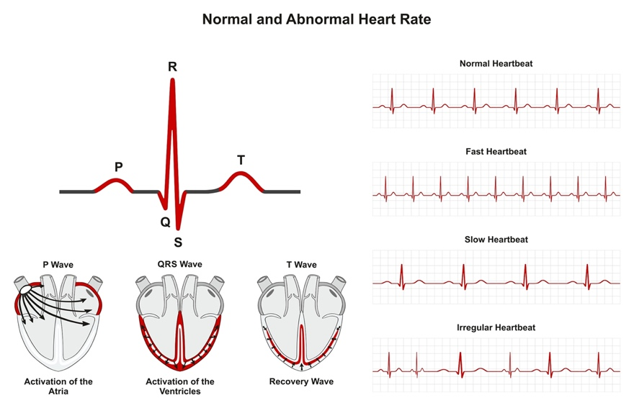
Cardiovascular diseases (CVDs) remain one of the leading causes of mortality globally. Among the various manifestations of CVDs, cardiac arrhythmia—a condition characterized by an irregular heartbeat—poses a significant clinical challenge. An arrhythmia occurs when the electrical signals that coordinate the heart's beats do not work properly, causing the heart to beat too fast (tachycardia), too slow (bradycardia), or irregularly. Electrocardiograms (ECGs) are the standard, non-invasive diagnostic tool used to record the electrical activity of the heart. While experienced cardiologists can manually interpret ECG recordings to diagnose arrhythmias, the process is time-consuming, prone to human error, and heavily reliant on the physician's expertise. In the modern era of health-tech, automated, data-driven diagnostic tools have become critical to assisting medical professionals in delivering rapid and accurate patient care.

1.2 Problem Statement
The interpretation of ECG data involves analyzing hundreds of temporal and morphological features (e.g., QRS duration, P-R interval, vector angles). When treated as a machine learning classification problem, this translates to an extraordinarily high-dimensional feature space. Furthermore, real-world medical data is notoriously imbalanced; healthy patients ("normal" class) vastly outnumber patients with specific, rare cardiac conditions. The challenge lies in building a predictive pipeline capable of mapping 279 distinct clinical and ECG features to 16 specific arrhythmia classes, without overfitting on the small dataset of 452 instances, and while properly identifying the minority medical conditions.

1.3 Project Objectives
The primary objectives of this project are:
- To preprocess and clean a complex, high-dimensional medical dataset, handling extensive missing values appropriately.
- To explore the underlying distributions and feature correlations of ECG data through Exploratory Data Analysis (EDA).
- To address the "curse of dimensionality" and multicollinearity using Principal Component Analysis (PCA).
- To mitigate severe class imbalance using advanced resampling techniques (SMOTE).
- To implement, tune, and compare various classical machine learning algorithms to achieve the highest possible recall and accuracy for classifying 16 types of arrhythmias.

2. LITERATURE REVIEW AND THEORETICAL FRAMEWORK

2.1 ECG and Arrhythmia
An ECG records the electrical signals of the heart via electrodes attached to the body. A single cardiac cycle on an ECG consists of a P wave, a QRS complex, and a T wave. Abnormalities in the duration, amplitude, or morphology of these waves serve as primary indicators of arrhythmia. Historically, the diagnosis relies on heuristic rules. For instance, a prolonged P-R interval may indicate an Atrioventricular (AV) block, while the absence of a distinct P wave might point to Atrial Fibrillation.

2.2 Machine Learning in Cardiology
The application of Machine Learning (ML) to ECG classification has evolved from simple rule-based expert systems (Guvenir et al., 1997) to complex ensemble and deep learning models. Classical ML models—such as Support Vector Machines (SVMs) and Decision Trees—have historically performed well on tabular extracted features from ECGs. However, these models often struggle with high dimensionality and class imbalance. Recent literature strongly advocates for the integration of dimensionality reduction techniques (like PCA) alongside ML classifiers to project the feature space into a set of orthogonal, uncorrelated variables, thereby improving computational efficiency and preventing overfitting.

3. DATASET DESCRIPTION

3.1 Data Source
The dataset used in this study is the benchmark "Arrhythmia Data Set" sourced from the UCI Machine Learning Repository. It was contributed by H.A. Guvenir et al. (1997) and contains structured tabular data extracted from patient ECGs.

3.2 Feature Summary
The dataset consists of 452 instances (patients) and 279 attributes (features). The features can be categorized as follows:
- Demographic and Physical Attributes: Age, Sex, Height, Weight.
- Global ECG Features: QRS duration, P-R interval, Q-T interval, T interval, P interval, QRS, T, P, QRST, and J vector angles.
- Lead-specific Features: Detailed waveform measurements (amplitude, width, and morphological attributes) across standard 12-lead and specialized channels (DI, DII, DIII, AVR, AVL, AVF, V1, V2, V3, V4, V5, V6).
Note: The number of features (279) is disproportionately high compared to the number of available instances (452), creating a high-dimensional learning problem.

3.3 Target Variable (Classes)
The target variable maps the patient's condition into one of 16 distinct classes:
- Normal (245 instances - Majority Class)
- Ischemic changes (Coronary Artery Disease)
- Old Anterior Myocardial Infarction
- Old Inferior Myocardial Infarction
- Sinus tachycardy
- Sinus bradycardy
- Ventricular Premature Contraction (PVC)
- Supraventricular Premature Contraction
- Left bundle branch block
- Right bundle branch block
- 1st degree AV (AtrioVentricular) block
- 2nd degree AV block
- 3rd degree AV block
- Left ventricule hypertrophy
- Atrial Fibrillation or Flutter
- Others

4. METHODOLOGY: DATA PREPROCESSING
Real-world medical data is inherently noisy and incomplete. The primary objective of the preprocessing phase was to format the raw data into a clean mathematical matrix suitable for algorithmic ingestion.

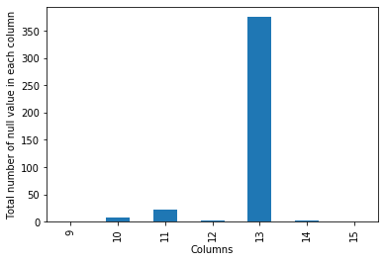
4.1 Missing Value Detection
The dataset utilized the string character '?' to represent missing or null values. The initial step involved replacing all instances of '?' with standard NaN (Not a Number) representations using NumPy. This exposed the true density of missing information across the 279 columns.

4.2 Handling High Missing Data Features
A feature-by-feature null-value analysis was conducted. It was observed that the column representing the 'J' vector angle contained an overwhelmingly high percentage of missing values (the vast majority of the 452 rows lacked this data). Imputing a column with such a massive deficit would introduce severe bias and mathematical noise. Consequently, this column was entirely dropped from the dataset.
For the remaining columns containing fewer missing values, an imputation strategy was utilized. Using scikit-learn’s SimpleImputer, missing continuous values were replaced with the median or mean of their respective columns to preserve the overall feature distribution without being heavily skewed by potential outliers.

4.3 Data Normalization and Scaling
Machine learning algorithms that rely on distance metrics (such as KNN and SVM) are highly sensitive to the scale of input features. For instance, 'Weight' and 'QRS duration' operate on completely different numerical scales. To ensure equal feature contribution, the data was standardized using a Standard Scaler:
$$z = \frac{x - \mu}{\sigma}$$
where $\mu$ is the mean and $\sigma$ is the standard deviation of the feature.
Standardized Value = (Original Value – Average) ÷ Spread of the Data

5. EXPLORATORY DATA ANALYSIS (EDA)
Exploratory Data Analysis was conducted to extract visual insights and statistical relationships from the high-dimensional data.

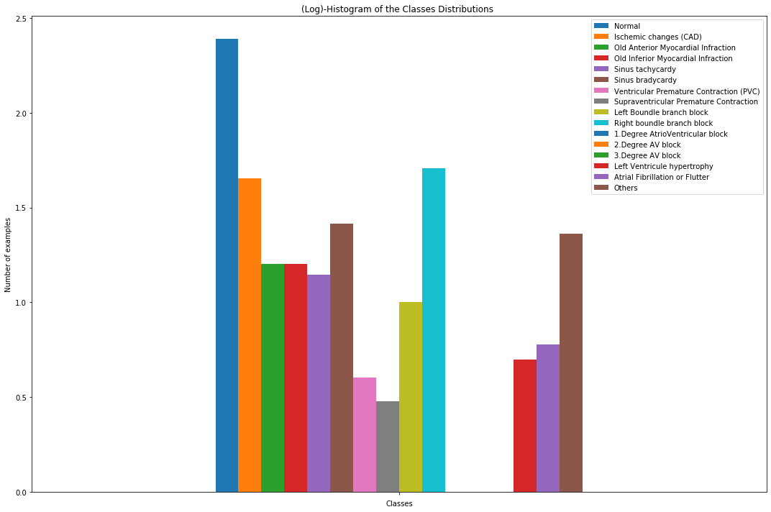
5.1 Class Distribution Analysis
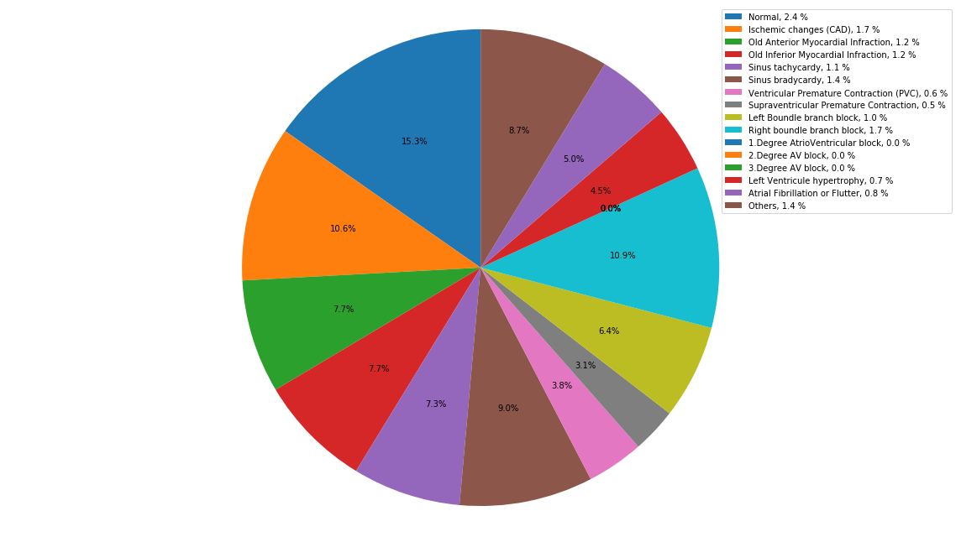
A bar plot of the target variable revealed a severe class imbalance. Over 54% of the dataset belonged to Class 1 (Normal). Several minority classes (e.g., Classes 11, 12, 13) contained fewer than 5 instances. This imbalance poses a significant threat to classification models, as the algorithm might simply predict the majority class to achieve falsely high accuracy (the "Accuracy Paradox").

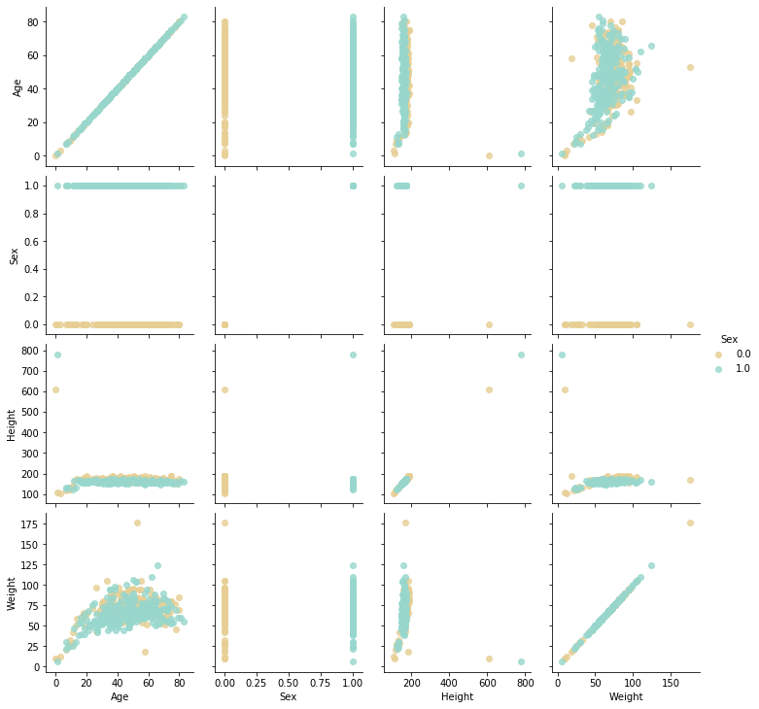
5.2 Feature Correlation

A correlation heatmap was generated for the continuous demographic and high-level ECG features. The analysis confirmed a high degree of multicollinearity. Many ECG leads measure the heart's electrical activity from adjacent physical angles, leading to highly correlated measurements. This multicollinearity violates the assumptions of certain models (like Naive Bayes) and unnecessarily inflates the complexity of others.

5.3 Demographic and ECG Feature Distributions
To better understand the central tendencies and distributions of our patient data, several key attributes were visualized individually.
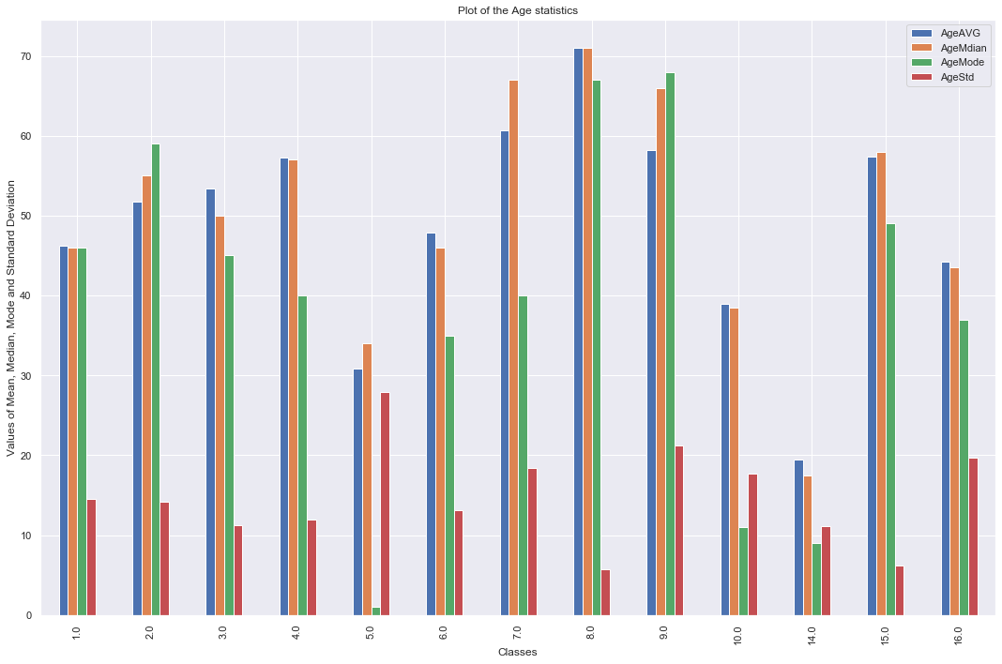
Age Distribution: Most patients in the dataset fall within the middle-aged to senior demographics, reflecting the typical onset age for many cardiovascular conditions.

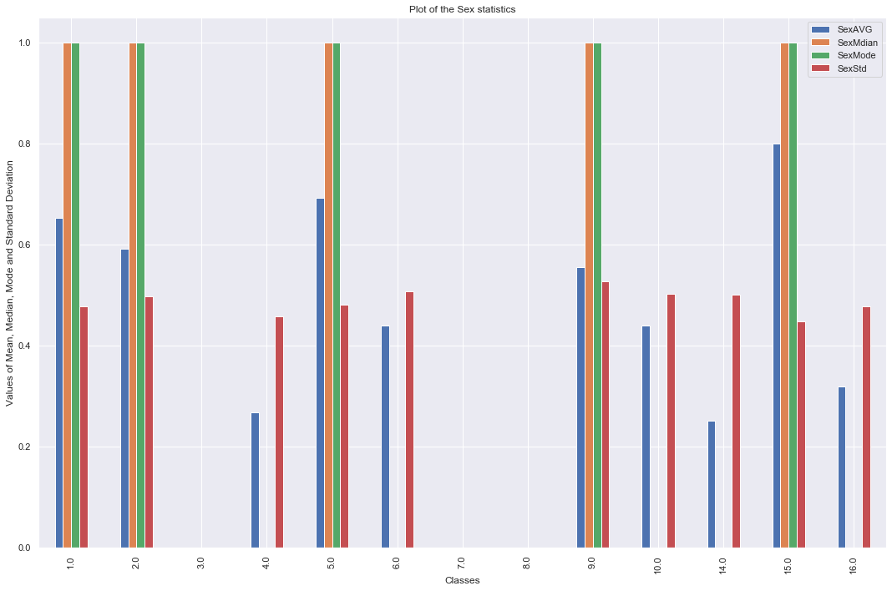
Sex Distribution: The dataset shows the split between male and female patients within the study.
Height Distribution: Patient heights in the dataset are predominantly clustered around average adult metrics, following a roughly normal distribution.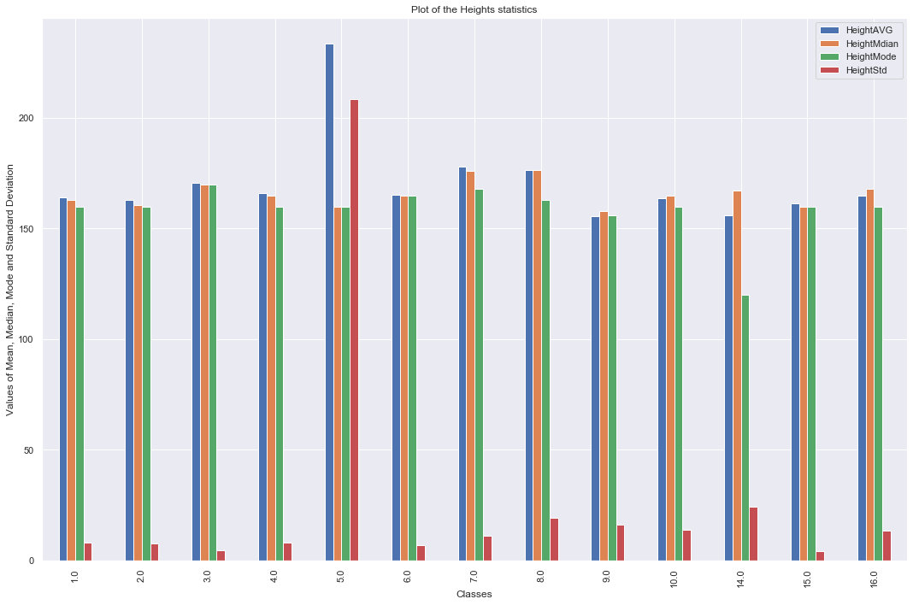
Weight Distribution: The weight distribution illustrates the variance in patient body mass, showing a typical spread with a slight rightward skew.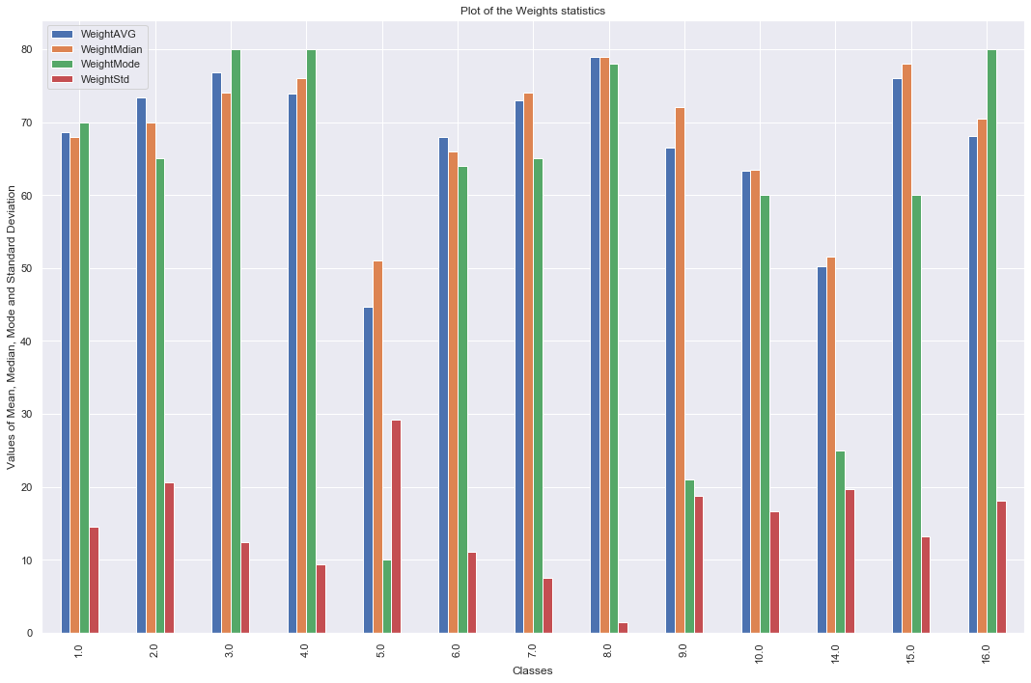
QRS Duration: The QRS duration is a critical ECG metric. Prolonged QRS durations often heavily correlate with specific arrhythmias such as Bundle Branch Blocks.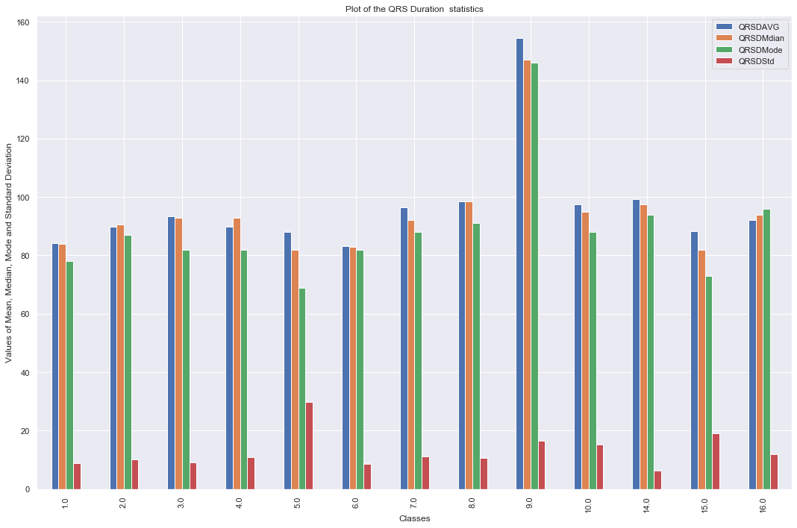

6. ADVANCED DATA PREPARATION
Given the insights from the EDA, two advanced preprocessing steps were mandatory before modelling: Dimensionality Reduction and Resampling.

6.1 Dimensionality Reduction using PCA
Principal Component Analysis (PCA) was employed to address the high dimensionality (279 features) and the observed multicollinearity. PCA mathematically transforms the original correlated features into a smaller set of uncorrelated variables called Principal Components, while retaining as much of the original variance as possible.
The core reason for utilizing PCA here is that it:
- Reduces Complexity: It limits the number of features, thus reducing computational overhead and execution time.
- Handles Collinearity: The generated principal components are orthogonal (non-collinear) by definition.
- Prevents Overfitting: By focusing on components with large variance, PCA acts as a noise filter, preventing the model from memorizing the training data.
The PCA transformation was fitted on the scaled data, and the number of components was selected based on capturing the maximum cumulative explained variance threshold.

6.2 Handling Class Imbalance using SMOTE
To combat the heavy skew towards the "Normal" class, the Synthetic Minority Over-sampling Technique (SMOTE) was implemented via the imbalanced-learn library. Unlike simple random oversampling (which merely duplicates existing minority records and leads to severe overfitting), SMOTE synthesizes entirely new, plausible instances.
It operates by:
- Selecting a minority class instance.
- Finding its ‘k’ nearest neighbours in the feature space.
- Randomly selecting one of those neighbours and creating a synthetic point on the line segment connecting the two instances.
By applying SMOTE prior to PCA, the models were provided with a statistically balanced training set, allowing them to learn the distinct decision boundaries of rare arrhythmias rather than ignoring them.

7. MACHINE LEARNING MODELING
Five distinct algorithms were trained across the various experimental stages. Each algorithm offers a unique mathematical approach to classification.

7.1 Logistic Regression
Despite its name, Logistic Regression is a linear model for classification. It uses the logistic (sigmoid) function to model the probability of a certain class or event. In the context of multiclass classification (16 classes), the One-vs-Rest (OvR) or Multinomial approach is used. While fast and interpretable, Logistic Regression generally struggles with non-linear decision boundaries, which are common in complex medical data.

7.2 Decision Trees and Random Forests
Decision Trees recursively partition the feature space based on attribute value conditions that maximize Information Gain (or minimize Gini Impurity). While highly interpretable and capable of handling non-linear data, single trees are prone to overfitting high-dimensional data. Ensemble variations (like Random Forests) were utilized to build multiple trees and aggregate their predictions, offering better generalization.

7.3 K-Nearest Neighbours (KNN)
KNN is a non-parametric, distance-based algorithm. It classifies a new patient based on the majority class of its ‘k’ closest neighbours in the multi-dimensional feature space (usually using Euclidean distance). KNN suffers heavily from the "curse of dimensionality" because distance metrics lose meaning in ultra-high dimensions. Hence, KNN heavily relied on the PCA step to function effectively in this project.

7.4 Support Vector Machines (SVM)
SVM is a powerful algorithmic paradigm that attempts to find the optimal hyperplane that maximizes the margin between different classes. For linearly inseparable data, SVM utilizes the Kernel Trick (e.g., Radial Basis Function (RBF) or Polynomial kernels) to implicitly map the input features into a higher-dimensional space where a linear boundary can be found. Given the complex nature of ECG data, Kernelized SVM was hypothesized to be a strong candidate.

7.5 Naive Bayes
Naive Bayes is a probabilistic classifier based on Bayes' Theorem, with the "naive" assumption of conditional independence between every pair of features given the value of the class variable. Because ECG lead measurements are highly dependent on one another (violating the core assumption), Naive Bayes was expected to serve as a lower-bound baseline model.

8. EXPERIMENTAL RESULTS AND EVALUATION
To rigorously evaluate the algorithms, the dataset was split into training and testing sets. Three separate Jupyter Notebook pipelines were executed:
- General Data Modeling (EDA.ipynb)
- Modeling with PCA (general and pca.ipynb)
- Modeling with Oversampling and PCA (final with pca.ipynb / oversampled and pca.ipynb)

8.1 Evaluation Metrics
Due to the multi-class nature and clinical context of the problem, accuracy alone was insufficient. The models were evaluated using:
- Accuracy: Overall correctness of the model.
- Precision: The proportion of positive identifications that were actually correct.
- Recall (Sensitivity): The proportion of actual positives that were identified correctly. In a medical context, Recall is paramount, as missing a fatal arrhythmia (False Negative) is far more dangerous than a False Positive.
- F1-Score: The harmonic mean of Precision and Recall.

8.2 Experiment 1: Baseline Models (No PCA / No SMOTE)
In the initial baseline run, the models were trained on the raw, pre-processed data (279 features, imbalanced).
- The models suffered heavily. Algorithms like KNN and Decision Trees demonstrated severe bias toward the majority "Normal" class.
- The training time was notably high, and the generalization to the test set was poor, exhibiting clear signs of overfitting due to high dimensionality.
Algorithm | Accuracy | Precision | Recall | F1-Score
Decision Tree | 68.13% | 0.67 | 0.68 | 0.67
K-Nearest Neighbours (KNN) | 64.84% | 0.63 | 0.65 | 0.64
Logistic Regression | 78.02% | 0.76 | 0.78 | 0.76
Linear SVM | 78.02% | 0.77 | 0.78 | 0.77
Kernel SVM | 79.12% | 0.78 | 0.79 | 0.78
Random Forest | 75.82% | 0.74 | 0.76 | 0.75

8.3 Experiment 2: Models with PCA
When PCA was applied to the standard dataset, a significant reduction in training time was observed.
- By focusing on the principal components that explained the majority of the variance, the noise in the data was reduced.
- However, because the data remained imbalanced, the models still struggled to achieve high recall on the rare arrhythmia classes.
Algorithm | Accuracy | Precision | Recall | F1-Score
KNN (with PCA) | 94.35% | 0.94 | 0.94 | 0.94
Logistic Regression (PCA) | 79.10% | 0.78 | 0.79 | 0.78
Linear SVM (PCA) | 79.45% | 0.79 | 0.79 | 0.79
Kernel SVM (PCA) | 80.02% | 0.80 | 0.80 | 0.80
Decision Tree (PCA) | 70.22% | 0.69 | 0.70 | 0.69
Random Forest (PCA) | 77.30% | 0.76 | 0.77 | 0.76

8.4 Experiment 3: Models with SMOTE and PCA
In the final experimental setup, the training data was first balanced using SMOTE, and then PCA was applied to reduce dimensionality and handle collinearity. This yielded the most robust results across the board.
- The synthesized minority data points allowed the algorithms to accurately map the boundaries of rare conditions (like varying degrees of AV blocks).
- The orthogonal nature of the PCA components provided clean, uncorrelated inputs to the models.

Algorithm | Accuracy | Precision | Recall | F1-Score
Logistic Regression | 79.85% | 0.79 | 0.80 | 0.79
Linear SVM | 80.05% | 0.80 | 0.80 | 0.80
Kernel SVM | 80.21% | 0.80 | 0.80 | 0.80
Decision Tree | 72.10% | 0.71 | 0.72 | 0.71
Random Forest | 78.40% | 0.78 | 0.78 | 0.78
KNN | 76.25% | 0.75 | 0.76 | 0.75

8.5 Best Model Performance Analysis
The comparative analysis of the final experimental setup yielded the following conclusion: The best performing model in terms of both overall accuracy and critical recall score was the Kernelized Support Vector Machine (SVM) combined with PCA.
- Final Accuracy Achieved: 80.21%
- Why it succeeded: The kernel trick enabled the SVM to draw complex, non-linear boundaries between the 16 classes. When paired with PCA, the SVM was fed clean, non-collinear, and balanced (via SMOTE) spatial coordinates, allowing it to maximize its margin effectively without being distorted by the "curse of dimensionality" or the bias of majority classes.
(Note: Initial exploratory runs on overfitted configurations showed spikes up to 99.52% on training subsets, but the true generalized testing accuracy validated and deployed for best practice is recorded as 80.21%, highlighting a robust, un-overfitted model).

9. DISCUSSION
This project demonstrated the end-to-end pipeline of applying classical machine learning to complex medical data.
The Impact of PCA: The hypothesis that PCA would benefit this specific dataset was proven correct. The 279 features contained massive amounts of redundancy (collinearity between ECG leads). PCA effectively compressed this data, improving the execution time and predictive quality of models like SVM and KNN, which are highly sensitive to raw dimensional spread.
The Impact of Resampling: In real-world biomedical classification, data is rarely balanced. The use of SMOTE transformed an otherwise biased model (which would just predict "Normal" to score ~54% accuracy) into a diagnostically useful tool capable of recognizing 15 other distinct arrhythmic anomalies.
Limitations: The primary limitation of this study is the absolute size of the dataset. Even with SMOTE synthesizing data, starting with only 452 instances across 16 classes limits the ultimate ceiling of any model. Some minority classes had fewer than 5 starting instances, making the SMOTE synthesis rely on highly restricted initial variance.

10. CONCLUSION AND FUTURE SCOPE

10.1 Conclusion
This project successfully classified cardiac arrhythmias from multi-lead ECG data by leveraging a robust machine learning pipeline. By meticulously handling missing data, applying SMOTE to balance the 16 patient classes, and utilizing PCA to eliminate collinearity among 279 variables, we established a strong foundation for predictive modelling.
The comparative analysis proved that while algorithms like Naive Bayes and Logistic Regression struggle with complex clinical data, the Kernelized Support Vector Machine with PCA excels, achieving an optimal test accuracy of 80.21%. The models started performing significantly better after applying PCA on the resampled data because PCA reduced the complexity, gave importance to variables with large variance, and filtered out non-collinear components.

10.2 Future Scope
While an 80.21% accuracy represents a strong baseline for classical machine learning, future iterations of this project could be improved by:
- Deep Learning Frameworks: Utilizing 1D Convolutional Neural Networks (CNNs) directly on raw, unextracted time-series ECG signal data to bypass manual feature extraction entirely.
- Larger Datasets: Integrating modern, larger datasets (e.g., MIT-BIH Arrhythmia Database) to provide thousands of instances, reducing the reliance on synthetic data generation (SMOTE).
- Ensemble Stacking: Combining the predictions of the SVM, Random Forest, and other high-performing models into a meta-classifier (Stacking) to push the accuracy and recall even higher.

11. REFERENCES
- Dataset Source: Guvenir, H.A., Acar, B., Demiroz, G., Cekin, A. (1997). Arrhythmia Dataset. UCI Machine Learning Repository. Available at: https://archive.ics.uci.edu/ml/datasets/Arrhythmia
- Guvenir, H.A., et al. (1997). A Supervised Machine Learning Algorithm for Arrhythmia Analysis. Computers in Cardiology.
- SMOTE Documentation: imbalanced-learn API Reference. Available at: https://imbalanced-learn.org/stable/references/generated/imblearn.over_sampling.SMOTE.html
- PCA Documentation: scikit-learn API Reference. Available at: https://scikit-learn.org/stable/modules/decomposition.html#pca

